The Presidential Nomination Process
Modified and adapted from KIdsCaucus, 1995.

The complex nomination process begins in Iowa with the state-wide precinct caucuses. The New Hampshire primary follows with Nevada next. Nominees from both the Democratic and Republican parties will be chosen in July at national party conventions. Between February and July, Democrats and Republicans will participate in a variety of primaries, conventions and caucuses to send delegates to the national convention who will officially cast their votes for the presidential candidates of choice. To find more information about which states and territories hold primaries, caucuses or state conventions and when head to: http://www.thegreenpapers.com/P16/.
What is a Primary?
There are two basic types of presidential primaries: the presidential preference primary and the delegate selection primary. In the presidential preference primary, party members vote directly for the person they wish to be nominated for president. In delegate selection primaries voters elect delegates to the national convention. Often a delegate will have announced support for a particular candidate prior to the primary. In effect, then, voters cast their ballots indirectly for the candidate of their choice.
States may use combinations of these methods to select delegates. In some cases, delegates are required to support particular candidates at the national convention for at least one ballot. The actual length of time these delegates are “bound” to a candidate varies from state to state. In other causes, states may hold “beauty contests” where the results of the primary have no binding effect on delegates. Most states hold presidential preference primaries where the vote binds delegates for one ballot.
Delegates from primary states are allocated in various ways. The two most common procedures are the winner-take-all method and the proportional method. In a winner-take-all method, the candidate receiving the most votes wins all of that state’s delegates. In a proportional primary, the delegates are divided among the candidates based on their percentage of the primary vote. Under the 2008 Democratic Party rules, delegates are selected by proportional representation, which requires a candidate to have 15% of a state’s popular vote to receive delegates. Changes in the rules for the 2013 Republican primaries will bring proportional representation to more states. To exemplify proportional representation, a candidate receiving 50% of the vote in a primary would receive 50% of the delegate from that state. Another candidate who received 25% of the vote receives 25% of the delegates. As stated previously, in Democratic primaries, a candidate must receive 15% of the vote in order to be eligible to have any delegate support. The Republican Party leaves this minimum percentage up to each state.
On many primary ballots, voters have the opportunity to elect “uncommitted” delegates to the national convention. These delegates are free to use their own judgement at the convention as to which candidate to support.
What is a Caucus?
Compared with a primary, the caucus system is more complicated. Instead of focusing on a single primary election ballot, the caucus is the first step in a process that involves meetings scheduled over several weeks or months. There is mass participation at the first level only, with meetings often lasting a few hours and attracting only the most enthusiastic and dedicated party members.
The operation of a caucus varies from state to state and each party has its own set of rules. Basically, the process begins with local precinct caucuses where participants meet in public halls and private homes throughout the state. Caucus-goers often publicly declare their support for particular candidates and elect delegates to the next stage in the process. In smaller states like Delaware and Hawaii, delegates are elected directly to the state convention. In larger states, there are a number of intermediate steps, including county and district conventions. At the state convention, delegates are selected to represent the state party at the national party convention. At this time, delegates are bound to support presidential candidates, similar to delegates from primary states.
Unlike voters in a primary, causes participants do more than just vote for a candidate. They precinct caucus and the following county, district and state conventions involved substantial discussion and debate of platform issues and party business. It requires a much greater time commitment on the part of caucus-goers than a primary voter. Because of the time commitment, caucus states usually have a lower rate of participation among voters than primary states.
The National Convention
The national conventions of the two major parties are characterized by fanfare, music, entertainment and deafening noise with an appearance of mass confusion, excited delegates, waving banners, balloons, pictures and slogans of party leaders.
Traditionally nation conventions were the place where bargains were made, deals were cut and candidates selected. For more than 100 years, the function of the conventions was to nominate the president and the vice-presidential candidates. With the increased role of primaries and the binding nature of delegate selection, candidates almost always have the nomination wrapped up before the convention begins. The role of the convention has been altered. Because they are televised, the purpose of a convention is now to kick off the general election campaign. The conventions launch the nominees and their running mates into the final months of the presidential campaign.
The symbolism of a political convention often begins with the choice of the city in which it will be held. In 2012, Republicans met in Tampa, Florida and the Democrats met in Charlotte, NC. In 2016, Republicans will meet in Cleveland, OH and Democrats will meet in Philadelphia, PA. The keynote speaker is chosen carefully. This person typically represents one of the stronger factions in the party. At the same time, he or she is expected to sound the themes of party unity and to act as a cheerleader, urging the party to victory.
Following the keynote address, which is given on the opening day, the convention divides into committees that consider such items as rules, qualifications of delegates, and, most importantly, the party platform.
Decisions about the content of the party platform are made by the platform committee in consultation with the party strategists. Although candidates struggle to have their ideas and policies reflected in the final document, the platform tends to be a general statement of party principles and philosophy.
Even though one candidate may have won a majority of the delegates in state caucuses and primaries, the names of many other candidates will be placed in nomination. IN addition to nominating speeches, there may be as many as a dozen seconding speeches, representing symbolic support from diverse groups of people.
After nominations are concluded, the balloting begins. While first-ballot victories have become the norm, the years, conventions have provided high drama. The nomination of Democratic candidate John Davis in 1924, for example, took 103 ballots over a four day period. The nominee was not clear until the very last ballot. During the 1880 Republican convention, 36 ballots were cast leaving James Garfield to be the nominee over two-term president Ulysses Grant. Garfield went on to win the presidential election, only to be tragically shot in July 1881-a few months after being sworn in.
In the past, the national party conventions marked the end of the nomination process. In more recent years, the conventions have really become the kick-off events of the general presidential campaign.

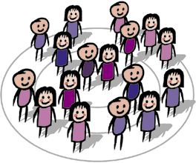
Caucus to Convention Flowchart
Precinct Caucuses (approximately 1770 statewide): Individual party members attend. In Iowa, usually in January or early February.
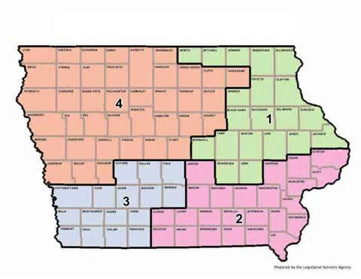
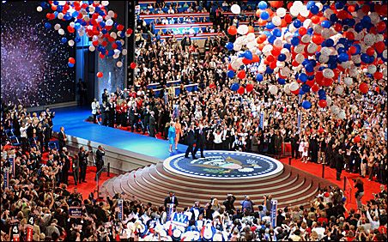
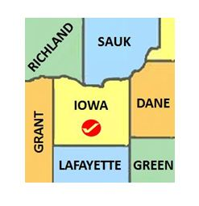
National Party Conventions
Usually held in July with the Democrats and Republicans meeting in different cities at different times.
County Conventions (One per county: ninety-nine total):
Usually held in March.
State Conventions & Delegate Selections
Usually held in June.
District Conventions (One per Congressional Districts for a total of four)
Usually held in April.

